Lesson Plan - 6

Grade/Subject: 2 Math Unit: Addition and Subtraction Strategies Lesson Duration: 60 Minutes

OUTCOMES FROM ALBERTA PROGRAM OF STUDIES
General Learning Outcomes:
Develop number sense
Specific Learning Outcomes:
Model comparison situations, and record the process with pictures and symbols
LEARNING OBJECTIVES
Students will:
1. Model comparison situations with pictures and symbols
2. Explain their process with pictures and symbols
3. Explore different strategies
ASSESSMENTS
Observations:  As you walk around watch and listen for indications that students can:  - Model and solve a comparison number story in different ways  - Write a number sentence to show how they solved a comparison problem |  |  | Key Questions:  - What is the difference?  - Can students take two groups, put them side by side to compare them and find the difference
Written/Performance Assessments:
- Completion of Activity 3.10
LEARNING RESOURCES CONSULTED
Resource #1: MathFocus
Resource #2: Teachers resources
Resource #3: Students work books
MATERIALS AND EQUIPMENT
* Jellybeans at least two different colors (I had 20 blue jelly beans, 20 pink, 10 green and 10 red)
* Snap cubes
* SMART board
* Rekenrek
PROCEDURE
Introduction (10 min.):
Hook/Attention Grabber: |  | Today we are going to use jellybeans to help us add!
Expectations for Learning and Behavior: |  | Do not eat the jellybeans still the end. (If you eat your jellybeans you will lose them and you will just have to watch me solve the problems on the smart board)
Advance Organizer/Agenda: |  | Sort jellybeans (or whatever you get into color groups)  Provide cubes and counters on the circle table for anyone who needs them  Agenda:  - Getting started with jellybeans  - Working on it
Transition to Body: |  | Hand out jellybeans and small ten sheets to student.  - Explain to students that as a class we will be finding the difference between groups using jellybeans and I will be doing it with them on the smart board so that they can follow along.
Body (45 min.):
Learning Activity #1:  Mention that we have a double (Remind them when ever you can) |  | Use Slide 1 to go through the first example:  - Lets say we have a group of 15 blue jellybeans and a group of 10 pink jellybeans  Walk students through the steps they will have the same thing in front of them as you do on the smart board. Let students know that they can follow along or if they know how many squares to fill in they may work at their own pace.  - Being able to have the solution in front of them and using their hands will hopefully keep them engaged  Ask students:  - How many more blue Jellybeans do we have?  Show students how to figure out the difference by matching the counters one to one.  - How many blue jellybeans do you need to match the Pink jellybeans?  - Which color of jellybeans do we have more of?  - How can you use subtracting to figure out how many extra jellybeans there are? (i.e. 15 – 10 = ___)  Once you have walked through the first example do one or two more.  - Do as many examples as needed  - Use the number line once to show student a different method.  - Explain to students that they should only use a number line when there isn’t a huge difference.
Assessments/Differentiation: |  | Observe students as you teach, ask prompt questions and make sure everyone is engaged and not just eating their jellybeans. Check for understanding whenever possible.
Learning Activity #2:  Scan the work sheet and put the image on the smart board for the students so they know what you are talking about and it is easier to explain the instructions to the students. |  | Ask students to turn to Activity 3.10 in their workbooks  - Have the star student hand them out.  - Let students know that they will be using their jellybeans to help them out so they should not eat them. If they want to try a different way of solving the problem they may use snap cubes, the number line on their desks or the rekenrek from the math kit. All items will be located on the circle table.  Move to Slide 8 and pose this problem:  - There are two teams. There were 17 children on one team and 8 children on the other team. How many children were on the bigger team?  Students can look for two different ways to compare the numbers using the tools you gave them. Have students record both ways on activity 3.10 and then create and solve a comparison problem of their own.
Assessments/Differentiation: |  | As students work, circulate and ask questions to encourage communication:  - How did you use the number line/jellybeans/cubes to solve the problem?  - What part of the number line/jellybeans/cubes shows the extra children on the bigger team?  Give feedback and discuss student’s answers. Invite students to share their solution strategies and explain their reasoning.
Sponge Activity: |  | Students can separate their jellybeans or snap cubes into a bigger group and a smaller group and then figure out how many more are in the bigger group.
Assessments/Differentiation: |  | Same as assessment above
Closure (5 min.):
Consolidation/Assessment of Learning: |  | Ask students to put away all of their supplies and collect activities for marking.
Feedback From Students: |  | Ask students if they have any questions.
Feedback To Students: |  | Answer any questions students may have. Give feedback as you walk around the classroom observing.
Transition To Next Lesson: |  | Let the students get ready for recess and tell them to enjoy your jellybeans

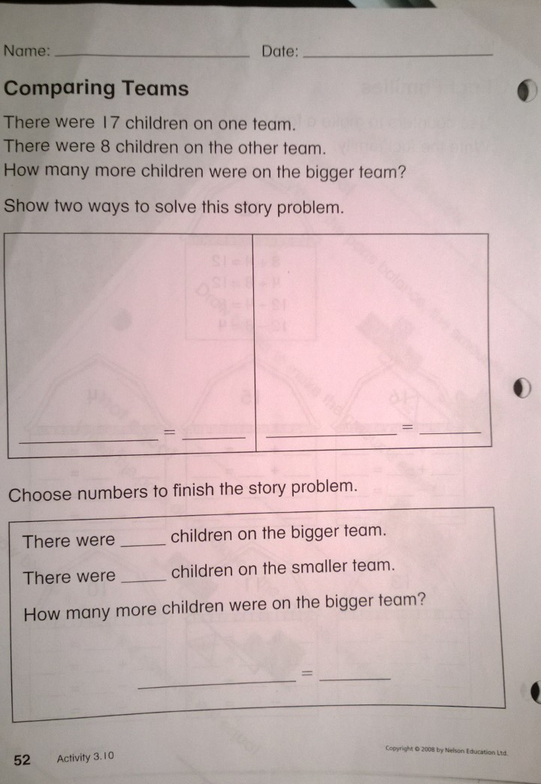
Lesson 7 – Investigating Fact Families

Grade/Subject: 2 Math Unit: Addition and Subtraction Strategies Lesson Duration: 60 Minutes

OUTCOMES FROM ALBERTA PROGRAM OF STUDIES
General Learning Outcomes:
Develop number sense
Specific Learning Outcomes:
Model and record fact families
#8 Demonstrate and explain the effect of adding 0 to, or subtracting 0 from, any number.
LEARNING OBJECTIVES
Students will:
1. Solve problems using fact families
2. Demonstrate the effect of adding 0 to or subtracting 0 from any number.
3. Explain their reasoning
ASSESSMENTS
Observations:  Watch and listen for indications that students can  - Generate fact families  - Describe the effect of adding/subtracting 0 |  |  | Key Questions:  Are students able to generate fact families?  Do students understand the effect of adding/subtracting 0?  Are students still aware of double facts?
Written/Performance Assessments:
- Completion of Activities 3.11 & 3.12
LEARNING RESOURCES CONSULTED
Resource #1: Math Focus
Resource #2: Teacher’s resources
Resource #3: Poster pack
MATERIALS AND EQUIPMENT
* 18 counters (9 big, 9 small)
* Smart board
PROCEDURE
Introduction (5 min.):
Hook/Attention Grabber: |  | Tell students you’re going to introduce them to your family
Assessment of Prior Knowledge: |  | Take a poll and ask: Does anyone remember what fact families are?
Expectations for Learning and Behavior:  * Write out expectations on the board  * If students break rules give out road rule lights |  | - Listen  - Be respectful  - TRY your best  - Raise hand if you need help I will come to you  - Stay in your desks
Advance Organizer/Agenda: |  | Advanced organizer:  - Pull up smart board presentation  Agenda:  - Introducing My Fact FAMILY  - How many cows in the barn?  - Sponge activity 3.12
Transition to Body: |  | Tell the students we will be learning about your fact family Introduce them to your family on Slide 1
Body (50 min.):
Learning Activity #1:  My fact family  *If smart board doesn’t work just draw family on the board |  | Using SMART board go through this scenario:  - Slide 1 – Once upon a time there was a family with 2 adults and 3 children.  - Write 2 + 3 =5 on the smart board  - Ask students: How else could I have written the number sentence that describes the family?  - Move to Slide 2 – Sometimes the 3 children in the family go outside to play.  - Write 5 – 3 =2 on the slide  - Move to Slide 3 – Other times, the adult’s work in the yard while the children play in the house.  - Write 5 – 2 = 3 on the slide  Transition: Give each student 18 counters (9 big and 9 small)  - Explain that the big counters represent full-grown cows and the small counters represent calves.
Assessments/Differentiation: |  | Observe students are they engaged and are they answering questions. Are they raising their hands to answer questions and do they have the right answer?
Learning Activity #2:  Barn Challenge |  | On Slide 4 there is a picture of a barn, write 12 on the roof, and pose this problem:  - 12 cows and calves live in the barn how many are cows and how many are calves?  Invite students to use their large and small counters to model one possible answer OR do it together as a class on the SMART board  Focus on one students model, and ask questions to generate the fact family:  - How many cows live in your barn?  - How many calves?  - What addition sentence tells that?  - How else could you write the addition?  - Imagine that just the calves went out to the field. What subtraction sentence tells that?  - What if the cows went out and the calves stayed in?  Using the smart board to write down number sentences, discuss a doubles mode and a model with 0:  - [Hailey’s] Barn has 6 cows and 6 calves.  - What number sentences can we write about these cows and calves?  - What can we only write two number sentences? (6+6=12; 12-6=6)  - What number sentence can you write about 12 cows and no calves? (12 + 0 = 12)  - When you add 0 calves, why is the answer the same as the number you started with?  - What other number sentences are in this fact family?  - (Look at the zero and same numbers strategies on poster 4A and 5A)  Provide activity 3.11. Have students model a fact family for each barn with counters and then record the fact family on the activity sheet.  Transition: When students are finished, ask them to raise their hand and let them know that you will tell them what to do next.
Assessments/Differentiation: |  | Observe students are they engaged and are they answering questions. Can they do the worksheet? Are they trying, how many questions are they asking?
Learning Activity #3:  Activity 3.12 |  | Read the glossary entry for fact family on Activity 3.12.  - Have students complete the entry and share their responses.
Assessment/Differentiation: |  | Invite students to share some of their fact families. Ask questions to prompt communication and reasoning. Collect worksheets for formative assessment.  If all the students seem to be struggling do it as a class.
Closure (5 min.):
Consolidation/Assessment of Learning: |  | Collect worksheets and make note of anyone who is struggling with this concept.
Feedback From Students: |  | Ask students if they have any questions
Feedback To Students: |  | Answer any questions they may have
Transition To Next Lesson: |  | Ask students to hand in their worksheets and put away the counters and get ready for lunch.

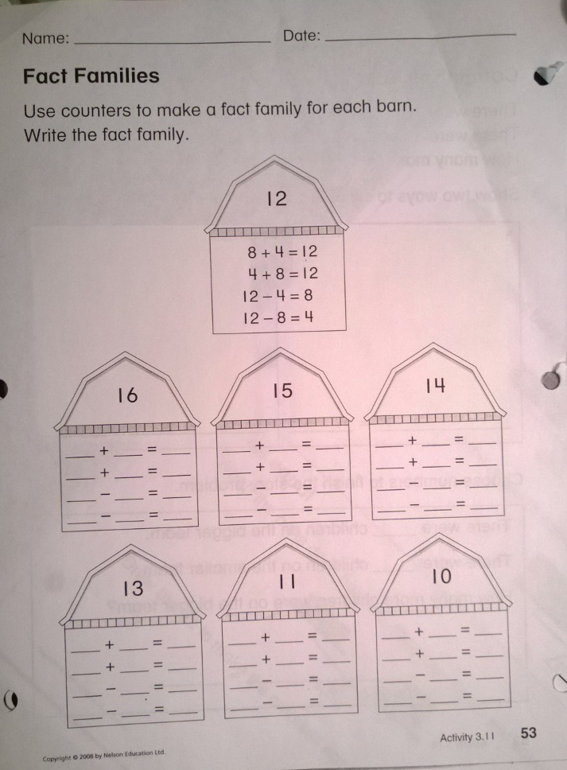

Lesson Plan - 8

Grade/Subject: 2 Math Unit: Addition &Subtraction Strategies Lesson Duration: 60 Minutes

OUTCOMES FROM ALBERTA PROGRAM OF STUDIES
General Learning Outcomes:
Developing number sense
Specific Learning Outcomes:
Identify and use patterns in an addition table
Create a story problem for a given solution
LEARNING OBJECTIVES
Students will:
1. Understand how to use a addition chart
2. Identify and use patterns in an addition table
3. Create a story problem for a given solution using knowledge from lesson
ASSESSMENTS
Observations:  Watch and listen for indications that students can  - Create a story problem for a given sum  - Locate sums and differences in an addition table |  |  | Key Questions:  What is an addition table for?  How does it work?  How can I use it to make addition easier for myself
Written/Performance Assessments:
- Formatively assess students through observation, discussion and the collection of student’s addition and subtraction stories. Give feedback and ask prompt questions when necessary but make sure to circulate and not get stuck helping one student because you will end up doing it for them and they will rely on you to much (Want to lead students to become independent learners)

LEARNING RESOURCES CONSULTED
Resource #1: MathFocus
Resource #2: Poster pack
MATERIALS AND EQUIPMENT
* SMART board
* Math 3.3: Addition Table (p. 61) 1 for each student
* Counters for modeling stories
* White sheet of paper for eac student
PROCEDURE
Introduction (5-10 min.):
Hook/Attention Grabber:
Assessment of Prior Knowledge: |  | Ask student:  - What do you think an addition table is for?  - How does it work?
Expectations for Learning and Behavior:  * Write out expectations on the board  * If students break rules give out road rule lights |  | - Listen  - Be respectful  - TRY FIRST  - Raise hand if you need help, I will come to you  - Stay in your desk
Advance Organizer/Agenda: |  | Advanced organizer:  - Set up smart board presentation.  Agenda:  - Demonstrate using addition tables  - Hidden numbers  - Addition/Subtraction stories
Transition to Body: |  | Today we will be using an addition table.
Body (40-45 min.):
Learning Activity #1:  Using Addition Tables |  | Print 4+5 = ___ and then draw straight lines from the addends 4 and 5 to show how to find the sum, 9. The addition table shows that 4 +5 = 9.  - What sum will I get if I add 5+4? Locate 5+4 on the table.  - Why is this sum the same as the sum for 4+5?  Print 9 – 4 =___  - How can I use the addition table to figure out 9-4?  Revisit the concept of adding and subtracting 0 by asking:  - If I had 0 eggs, could I eat them? Why not?  - If I had 3 eggs and I got 0 more, how many would I have?  Use the addition table to confirm that 3+0=3  Make a connection to patterns by asking:  - What number patterns do you see in the table?  - Discuss some of the patterns that are described in the Math Note.
Assessments/Differentiation: |  | Observe students answers if they respond, and observe who is not responding because not every student will respond. If students are disengaged ask them a question. Try phrasing questions differently if students do not comprehend.
Learning Activity #2:  Hidden Numbers and patterns |  | Transition: Ask the students to cover their eyes (its not necessary but might be fun anyway)  Move to Slide 2; a few numbers will be covered up. Tell students they can open their eyes and ask them which numbers are hidden?  - How did you know that this number was [whatever number it is, maybe 3]?  When you uncover the whole table, ask:  - Do you see any patterns that you didn’t notice before?  Move to Slide 3. While students look away and cover the sum of 6+7 =13 on the addition table.  - What number is hidden?  - How do you know?  - Where else do you see 13 on the addition table?  - What adding and subtracting stories can you tell about 13 things?
Assessments/Differentiation: |  | Observe: Are students able to identify the hidden number and explain how they did it.
Learning Activity #3:  Addition/Subtraction stories  Example:  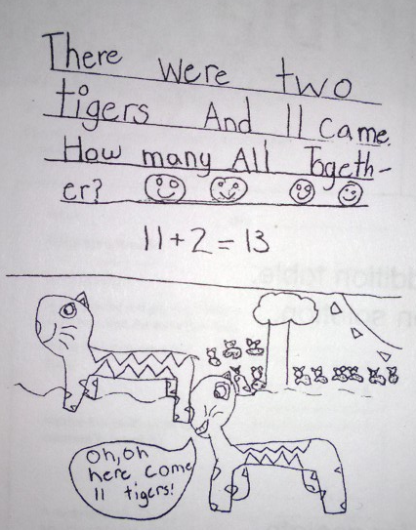 |  | Put an example of an addition story.  Give each student:  - Math 3.3  - Counters for modeling stories  - A piece of paper for recording their stories  Ask students to write and illustrate an:  - Addition story about 13 on the front of the piece of paper  - A subtraction story about 13 on the back  - Then ask them to write the addition or subtraction number sentence that goes with each story.  Encourage them to use the 13s in the table to help them. Help students begin by asking questions to spark their reasoning:  - What numbers might you use in an adding or subtracting story about 13?  - How can the addition table help you choose numbers to use?  - Are there numbers you could use that you don’t see on the table?
Assessment/Differentiation: |  | As you walk around observe and discuss stories with students make sure students are not just copying each other (Maybe put some sort of template for students if you find that they are struggling.) Discuss students answers with them try getting them to think critically by asking prompt questions.
Closure (5 min.):
Consolidation/Assessment of Learning: |  | Ask students to put supplies and collect student’s number stories.
Feedback From Students: |  | Ask students if they have any questions
Feedback To Students: |  | Answer any questions that students may have. Give feedback if necessary and summarize the lesson.
Transition To Next Lesson: |  | Students may start getting ready for lunch

Rational:
Let me just start by saying that I am NOT a math person. Teaching math has been as challenging as it has been interesting. When planning my lessons, I made decisions based on the answer to these two questions; “What would make me want to learn math?” and “What would make me want to teach math?” I wanted to make the lessons fun to teach so that it would be fun to learn, because I realize my attitude effects the way I teach. Whilst planning, my intentions for each lesson were to create a positive environment and for the lessons to be engaging and relatable. Upon reflection I realized that there is a fine line between engagement and distraction; I need to find that balance.

When creating a positive environment each class, I started with myself; I maintain a positive attitude. Either I wrote my expectations on the board or I went over them with the students at the start of each of the three lessons. I asked students to try their best and ask for help if they really didn’t know. I am always honest with my students. I admit when I have made a mistake and that I am forgetful; which is why I write everything down in my lesson plans and sometimes reference them.

In the first lesson, Lesson 6, I included jellybeans. I had hoped that this would create a positive learning environment and get the students super engaged, which they were. I did the same problem they were doing on the smart board so they could follow along. I thought by having them solve the problems at their desks they would be more focused. This did not really happen, the problem was that students were a little distracted; they were almost too engaged (They really wanted those jellybeans). I tied lesson 6 and 7 together by showing the students how to create Fact Families by grouping. Lesson 7 was engaging for the students because I used my own family as an example in an attempt to make myself more human to the students. This only sort of worked. I think my explanation confused the students, because I was learning with the students. I understood the concept I was teaching, but I had not found a good way to explain it yet. Then it hit me, as I was half way through another example, so my explanation was a bit slow and broken. The explanation was a solid one but I just need to be more prepared next time and have it in my lesson plan. I tied lesson 7 and 8 together by asking students to help my find and create the fact families (I was pleasantly surprised when I learned that some of them had understood the last lesson). Lesson 8 was my best lesson it was the perfect mix of exciting and serious. There was nothing special about the lesson except that I tried to make it super fun for the students by the way I explained things. I also drew pictures for the students… they loved that. I made sure to be consistent and I think this really helped keep the students focused and engaged. I took my time with the explanations as well.

What all three lessons have in common is that the students would follow along and understand when I was explaining to them on the board but as soon as I asked them to work on their own they were lost. Unfortunately, they have to complete worksheets, but I think the next time I teach 3 consecutive lessons, I might go through examples that look exactly like what is on their worksheets. Also, I think the students get confused when a worksheet is put in front of them, they don’t realize what is the important information and start taking info from everywhere. These three lessons are about teaching strategies. If teaching these lessons again the first strategy I would teach the students is to highlight the important information. I want to set the students up for success.

I have learned that my attitude and understanding for the lesson has the biggest effect on how smoothly it runs. When writing lesson plans it’s always good to understand what you are writing and try to think of ways to tie it into the last lesson because the students may not get the lesson you are teaching in the moment, but they will understand the previous lesson a little better.

